A PROJECT REPORT ON “Food Waste Redistribution App”
A Dissertation Report
Submitted in partial fulfillment of the requirements for the award of the degree of
“BACHELORE OF COMPUTER APPLICATION” UNDER BENGALURU NORTH UNIVERSITY, KARNATAKA


FOR THE ACADEMIC 2025-2026 SUBMITTED
BY:
Ms. Lavanya N (U19CU23S0062),
Mr. K Pon Subash (U19CU23S0063),
Mr. Jagan G (U19CU23S0069)
UNDER THE GUIDENCE OF
MR. PRAKASHAM
Department of Computer Applications
KRUPANIDHI DEGREE COLLEGE


KRUPANIDHI DEGREE COLLEGE
2/1, ChikkaBellandur, Carmelaram Post Varthur Hobli, Off Sarjapur Road, Bangalore,
Karnataka - 560035
(RECOGNISED BY THE BENGALURU NORTH UNIVERSITY)



CERTIFICATE
This is to certify that the project work entitled “Food Waste Redistribution App” Was completed by Ms. Lavanya N (U19CU23S0062), Mr. K Pon Subash (U19CU23S0063), Mr. Jagan G (U19CU23S0069) in partial completion of the award degree Bachelor of computer Applications from Bengaluru North University during the year 2025-2026.The project report has been approved because it fulfills academic requirements as required for the degree.

DECLARATION BY THE STUDENT

I hereby certify that “Food Waste Redistribution App” is the result of the project work carried out by me under the guidance of Mr. Prakasam, Assistant Professor in partial fulfillment for the award of Bachelor of Computer Applications from Bangalore North University.
I further certify that this project is the result of my own work and has not been submitted to any other university or institution for the awarding of any other degree, diploma, or certificate.

Place: Bengaluru Name: Lavanya N
Date: K Pon Subash
Jagan G

GUIDE CERTIFICATE

This is to confirm that the project report titled “Food Waste Redistribution App” is an original work Ms. Lavanya N, Mr. K Pon Subash, Mr. Jagan G University Reg No. U19CU23S0062, U19CU23S0063, U19CU23S0069 and is being submitted in partial fulfillment for the award of the Bachelor of Computer Applications of Bengaluru North University.

Place: Bengaluru Guide Signature
Date:

ACKNOWLEDGEMENT

I Would like to thank all those who have guided and encouraged me to do what has been done thus far. I avail the opportunity to express our deep sense of gratitude and sincere thanks to our department of Bachelor of computer Applications.
I am deeply thankful to Dr. Suresh Nagpal, Chairman of the KRUPANIDHI GROUP OF INSTITUTION. I acknowledge my delightful thanks to Ms. Geetha Nagpal, the Vice Chairman Person, KRUPANIDHI GROUP OF INSTITUTION.
I would like to sincerely thank our dean BADRUNNISA S, KRUPANIDHI DEGREE COLLEGE, for providing us with the necessary facilities.
I express deep gratitude to my guide Mr. PRAKASAM for her valuable advice, timely suggestions and assistance in the realization of this major project. My heartful thanks to all the staff members and non-teaching staff of the computer science department for providing the necessary facilities and support. Without the support of any one of them this project would not have been reality.
I am also grateful to my friends for their valuable suggestions for the success of the project. I also thank my parents for their support in all our activities, without which I would not have been able to carry out the project.

Place: Bengaluru Name: Lavanya N
Date: K Pon Subash
Jagan G

TABLE OF CONTENTS

Chapter No. | Particulars | Page no.
01 | INTRODUCTION  1.1 Introduction to project  1.2 Objective of project  1.3 Scope of project  1.4 Module description
02 | SYSTEM REQUIREMENT SPECIFICATION  2.1 Software Requirement  2.2 Hardware Requirement  2.3 Technical Requirement
03 | SYSTEM ANALYSIS  3.1 System Study  3.2 Existing System  3.3 Proposed System
04 | SYSTEM DESIGN  4.1 Entity Relation Diagram  4.2 Data Flow Diagram  4.3 Database tables
05 | CODING  5.1 Frontend  5.2 Backend  5.3 Screenshot
06 | SYSTEM TESTING
07 | FUTURE ENHANCEMENT
08 | CONCLUSION
09 | BIBLOGRAPHY

ABSTRACT

Food Waste Redistribution App: A Web-Based Food Waste Redistribution Platform Food waste is one of the most pressing global challenges of our time. Approximately one-third of all food produced worldwide is wasted annually, while millions of people continue to face hunger and malnutrition every day. This contradiction is not merely a supply problem — it is fundamentally a connectivity and logistics problem. Surplus food exists in abundance at restaurants, hotels, catering services, and households, yet no efficient mechanism exists to redirect it to those in need.
Food Waste Redistribution App is a web-based food waste redistribution platform developed to bridge this gap. The system provides a structured, role-based environment where food donors — including restaurants, caterers, and households — can post surplus food listings with details such as food type, quantity, expiry time, pickup address, and photographs. Receivers, such as NGOs, community shelters, and individuals in need, can browse these listings in real time, apply filters by category or dietary preference, and submit claims for available food. Donors can then review incoming claims, approve or reject them, and mark exchanges as completed once the food has been successfully collected.
The application is developed using Python and the Django web framework, following the Model-View-Template (MVT) architectural pattern. It incorporates a role-based access control system supporting three distinct user types — Donor, Receiver, and Admin — each with a personalised dashboard and controlled permissions. Core functionalities include full CRUD operations on food listings and claims, an in-app notification system that triggers alerts at every key action, a star rating and trust scoring system that builds community credibility over time, and a responsive, intuitive user interface built with Bootstrap 5.
The database is designed using Django's ORM with SQLite for development, comprising six models: Custom User, Food Listing, Category, Claim, Review, and Notification. The platform supports category-based filtering, keyword search, vegetarian filtering, and automatic expiry detection to ensure only relevant and timely listings are displayed to receivers.
Food Waste Redistribution App demonstrates how focused software engineering can address real-world social challenges. By connecting food donors and receivers through a transparent, trust-driven platform, the system contributes meaningfully to reducing food waste, alleviating hunger, and fostering community responsibility. The project serves as a comprehensive demonstration of full-stack web development skills encompassing database design, backend logic, frontend development, user authentication, and role-based workflow management.
CHAPTER 1: INTRODUCTION

1.1 Introduction to the Project
In today's rapidly urbanising world, food waste has emerged as one of the most critical environmental and humanitarian challenges. According to the Food and Agriculture Organisation (FAO) of the United Nations, approximately 1.3 billion tonnes of food is wasted globally every year — accounting for nearly one-third of all food produced for human consumption. Paradoxically, while enormous quantities of edible food are discarded daily, an estimated 828 million people worldwide go to bed hungry every night. This glaring contradiction is not simply a matter of food scarcity — it is, at its core, a problem of distribution, communication, and connectivity.
In cities like Chennai, Hosur, Bengaluru, and across India, restaurants complete their daily service with trays of unsold food, catering companies finish events with surplus portions, and households regularly discard excess groceries. At the same time, local NGOs, old-age homes, orphanages, and community shelters struggle to meet daily meal requirements for the people they serve. The food that could feed dozens of people is instead sent to waste, simply because no efficient bridge exists between the two ends of this equation.
Food Waste Redistribution App is a web-based food waste redistribution platform designed and developed to solve exactly this problem. The platform serves as a digital bridge — connecting food donors who have surplus food with receivers who need it, in a structured, transparent, and trust-driven manner. The name "Food Waste Redistribution App" reflects the spirit of the project: paying it forward by feeding those in need with food that would otherwise go to waste.
Food Waste Redistribution App is built using Python and the Django web framework and follows a clean Model-View-Template (MVT) architectural pattern. It provides a fully functional web application with role-based access for three types of users — Donors, Receivers, and Administrators — each with a personalised experience tailored to their needs. The platform supports the complete lifecycle of a food donation: from posting a listing and submitting a claim, to approving, collecting, and reviewing the exchange.
The project is developed as a Final Year academic project, demonstrating the practical application of full-stack web development concepts including database design, backend development, frontend UI design, user authentication, CRUD operations, and role-based workflow management — all in the context of a real-world social problem.

1.2 Objectives of the Project
The primary aim of Food Waste Redistribution App is to create a reliable, user-friendly, and impactful web platform that reduces food waste by redistributing surplus food to those who need it. The following objectives define the scope of work undertaken in this project:
1. To design and develop a fully functional CRUD web application The core objective is to build a complete web application that supports Create, Read, Update, and Delete operations across all key entities — food listings, user accounts, claims, reviews, and notifications — using Python and Django.
2. To implement a role-based access control system the platform must support three distinct user roles — Donor, Receiver, and Admin — each with clearly defined permissions and a personalised dashboard. Access to specific features and pages must be controlled based on the user's role.
3. To build an end-to-end food donation and claiming workflow the system must support the complete lifecycle of a food exchange: a donor posts food → a receiver claims it → the donor approves or rejects → the food is collected → the exchange is marked complete → a review is submitted.
4. To develop a responsive and attractive user interface the frontend must be visually appealing, mobile-friendly, and easy to navigate for users of all technical backgrounds. The UI is built using Bootstrap 5, custom CSS, and Google Fonts to ensure a professional and accessible experience.
5. To implement an in-app notification system Every key action on the platform — submitting a claim, approving it, rejecting it, or completing an exchange — must automatically generate a notification for the relevant user, keeping all parties informed at every stage.
6. To build a community trust and rating system After each completed food exchange, receivers must be able to rate donors on a scale of 1 to 5 stars and leave a comment. The donor's trust score must be automatically updated based on all received ratings, promoting accountability and reliability.
7. To demonstrate real-world social impact through technology the project aims to show how software engineering skills can be applied to address real humanitarian challenges — reducing food waste, fighting hunger, and building community trust — not just as a technical exercise, but as a genuinely useful platform.
8. To provide a scalable and maintainable codebase the project must be structured using Django's multi-app architecture, with clean separation of concerns across modules, so that new features can be added easily in the future without disrupting existing functionality.

1.3 Scope of the Project
The scope of Food Waste Redistribution App defines the boundaries of what the system covers within this project, as well as what lies outside its current implementation.
Within Scope
- User Management The system supports complete user registration, login, logout, and profile management. Users can upload a profile photo, update personal details, and view their trust score. Three roles are supported: Donor, Receiver, and Admin.
- Food Listing Management Donors can create food listings with a title, description, food category, quantity, number of servings, pickup address, expiry date and time, food photo, and a vegetarian/non-vegetarian indicator. Listings can be edited and deleted by the donor who created them.
- Food Browsing and Filtering Any visitor — logged in or not — can browse all available food listings. Filters include keyword search, food category, and vegetarian preference. Expired listings are automatically hidden from the browse page.
- Claim Management Receivers can submit a claim on any available listing with a personalised message and preferred pickup time. Donors can approve, reject, or mark claims as complete. Receivers can cancel their own pending or approved claims.
- Notification System Automatic in-app notifications are generated for the following events: new claim submitted, claim approved, claim rejected, and exchange completed. Notifications are displayed in a dedicated page with read/unread indicators.
- Reviews and Trust Scoring After an exchange is completed, receivers can leave a star rating (1–5) and a written comment for the donor. The donor's trust score is recalculated automatically as the average of all ratings received.
- Personalised Dashboards Each user role has a unique dashboard: Donors see their listing stats and activity table; Receivers see their claim stats and history; Admins see platform-wide stats and recent activity.
- Admin Panel A built-in Django administration panel at /admin/ allows the admin to manage all users, listings, claims, reviews, categories, and notifications with full CRUD capabilities.
- Responsive UI The entire frontend is responsive and works across desktops, tablets, and mobile devices using Bootstrap 5's grid system.

Outside Scope (Future Enhancements)
The following features are identified for future development but are not included in the current version of the project:
- Real-time push notifications using WebSocket’s or Django Channels
- Interactive map integration for visualising pickup locations
- Email and SMS alerts for claim updates
- Mobile application (Android/iOS) using React Native or Flutter
- Automatic expiry detection using Celery background tasks
- Social login via Google or Facebook (OAuth)
- Multi-language support for regional Indian languages
- PostgreSQL database for production deployment
- Food analytics dashboard with charts and impact metrics
- QR code generation for verified in-person pickup confirmation

1.4 Module Description
Food Waste Redistribution App is built as a Django multi-app project, where each major feature of the platform is encapsulated in its own independent module (Django app). This modular design ensures clean separation of concerns, easier maintenance, and the ability to extend individual modules without affecting others.
The platform consists of the following 6 modules:
Module 1 — Users Module (users)
Purpose: Handles all aspects of user identity, authentication, and account management.
Key Components:
- models.py - Defines the Custom User model which extends Django's built-in Abstract User. Additional fields include role (donor/receiver/admin), phone, address, profile photo, trust score, bio, and is verified.
- views.py - Contains views for register view, login view, logout view, profile view, and dashboard view.
- forms.py -Defines Register Form (with role selection), Login Form, and Profile Update Form.
- urls.py - Routes for /users/register/, /users/login/, /users/logout/, /users/profile/.
- dashboard_urls.py -Routes for /dashboard/.
Features Provided:
- User registration with role selection (Donor or Receiver)
- Secure login and logout with session management
- Profile editing with photo upload
- Role-based dashboard with personalised statistics
- Trust score display on donor profiles

Module 2 — Listings Module (listings/)
Purpose: The core module of the platform. Manages all food listing operations including creation, browsing, editing, and deletion.
Key Components:
- models.py — Defines two models: Category (name, icon) and Food Listing (donor, title, description, category, quantity, serves, photo, pickup address, status, expiry time, siege).
- views.py — Contains home view, listing list, listing detail, listing create, listing edit, and listing delete.
- forms.py — Defines Food Listing Form with a datetime picker for expiry time.
- management/commands/seed_data.py — A custom Django management command (python manage.py seed data) that pre-populates 8 default food categories.

Features Provided:
- Home page with hero section, latest listings, and statistics
- Browse page with keyword search, category filter, and veg filter
- Listing detail page with full information and claim button
- Create/Edit/Delete listing (Donors only, with ownership check)
- Automatic status management (available, claimed, expired, completed)
- Food photo upload and display

Module 3 — Claims Module (claims/)
Purpose: Manages the entire claim lifecycle — from a receiver submitting a claim to a donor completing the exchange.
Key Components:
- models.py - Defines the Claim model linking Food Listing and Custom User (receiver), with fields for status, message, and pickup time. Enforces unique together to prevent duplicate claims.
- views.py - Contains claim create, my claims, donor claims, claim action (approve/reject/complete), and cancel claim.
- forms.py -Defines Claim Form with message and pickup time fields.
Features Provided:
- Receivers can submit one claim per listing with a personalised message
- Donors can view all incoming claims in a management table
- Approve action: claim status → approved, listing status → claimed
- Reject action: claim status → rejected
- Complete action: claim status → completed, listing status → completed
- Cancel action: receiver can cancel; listing reverts to available
- Automatic notification triggered at every status change

Module 4 — Reviews Module (reviews/)
Purpose: Enables receivers to rate and review donors after a food exchange is completed, building a community trust layer across the platform.
Key Components:
- models.py — Defines the Review model with reviewer, reviewee, listing, rating (1–5, validated), and comment. Enforces unique together to allow only one review per listing per user.
- views.py — Contains add review which saves the review and recalculates the donor's trust score using Django's Av aggregation.
- forms.py — Defines Review Form with a radio button star selector.
Features Provided:
- Star rating from 1 to 5 with optional written comment
- One review per listing per user (enforced at database level)
- Automatic recalculation of donor's trust score after each review
- Reviews displayed on the listing detail page

Module 5 — Notifications Module (notifications/)
Purpose: Provides an in-app messaging system that keeps all users informed about actions relevant to them, without requiring any manual effort.
Key Components:
- models.py — Defines the Notification model with user, message, is read, and created at fields.
- utils.py — Defines the create notification (user, message) helper function used throughout the project to create notifications from any view.
- views.py — Contains notification list which displays all notifications for the logged-in user and marks all unread ones as read.
Features Provided:
- Automatic notification creation triggered from claims and reviews modules
- Notification list page showing all alerts newest-first
- Visual distinction between read and unread notifications
- Unread indicator (green dot) on each unread notification

Module 6 — Config Module (config/)
Purpose: The Django project configuration module. Not a feature module, but the backbone that connects all other modules together.
Key Components:
- settings.py — All project settings including installed apps, database configuration, authentication settings, media file paths, static file settings, and third-party package configuration.
- urls.py — The root URL router that includes URL patterns from all five feature modules.
- wsgi.py — The WSGI entry point for deploying the application to a production web server.
Module Interaction Diagram
┌─────────────┐
│ config/ │← connects everything
└──────┬──────┘
│
┌───────────┼────────────┐
▼ ▼ ▼
┌────────┐ ┌──────────┐ ┌─────────┐
│ users/ │ │ listings/ │ │ claims/ │
└────┬───┘ └────┬─────┘ └────┬────┘
│ │ │
└──────────┼─────────────┘
│
┌───────┴────────┐
▼ ▼
┌──────────┐ ┌───────────────┐
│ reviews/ │ │ notifications/ │
└──────────┘ └───────────────┘
Every module interacts with the user’s module (since all actions are performed by users) and the notifications module (since all key actions trigger alerts). The listings module is the central data module that claims and reviews depend on.

Chapter 2: System Requirements Specification

2.1 Software Requirements
The software requirements for Food Waste Redistribution App are categorised into development environment requirements, functional software requirements, and runtime requirements. These define the software tools, frameworks, libraries, and environments needed to develop, run, and maintain the application.

2.1.1 Development Environment

Software | Version | Purpose
Operating System | Windows 10/11, macOS, or Ubuntu 20.04+ | Python3.10 or higher Core programming language for backend
Python | 3.10 or higher | Core programming language for backend
pip | Latest (23.x+) | Python package manager for installing libraries
Virtual Environment (ven) | Built-in with Python | Isolated Python environment for dependency management
Visual Studio Code | Latest | Recommended code editor / IDE
Git | 2.x or higher | Version control system (optional but recommended)
Web Browser | Chrome / Firefox / Edge (latest) | For testing and using the application
Command Prompt / Terminal | Built-in OS tool | For running Django management commands
2.1.2 Backend Software Requirements
Library / Framework | Version | purpose
Django | 4.2.7 | Core web framework — URL routing, ORM, views, templates, admin
Django rest framework | 3.14.0 | REST API support for future mobile app integration
Django rest framework-simplejwt | 5.3.0 | JWT token-based authentication for API endpoints
Pillow | 10.x | Image processing library for profile photos and food photos
python-decouple | 3.8 | Reads environment variables from .env file for secure config
Django-cors-headers | 4.3.1 | Handles Cross-Origin Resource Sharing (CORS) for API access
White noise | 6.6.0 | Serves static files (CSS, JS, images) efficiently in production
Django-crispy-forms | 2.1 | Renders Django forms with Bootstrap styling automatically
crispy-bootstrap5 | 0.7 | Bootstrap 5 template pack for crispy forms

2.1.3 Frontend Software Requirements
Technology | Version | Purpose
Django Templates | Built-in | Server-side HTML rendering engine
Bootstrap | 5.3.0 | Responsive grid, components, and layout utilities
Bootstrap Icons | 1.11.0 | Icon library used throughout the UI
Google Fonts — Fraunces | Latest | Display/heading font for brand identity
Google Fonts — DM Sans | Latest | Body text font for readability
Vanilla CSS | — | Custom styles, CSS variables, animations, design tokens
Vanilla JavaScript | ES6+ | Client-side interactivity (star rating, role selector, alerts)

2.1.4 Database Software Requirements
Software | Version | Purpose
SQLite | 3.x (bundled with Python) | Default database for development — no separate installation needed
PostgreSQL (optional) | 14.x or higher | Recommended for production deployment
psycopg2-binary (optional) | 2.9.x | PostgreSQL adapter for Django (required only if using PostgreSQL)
Django ORM | Built-in with Django | Object-Relational Mapper for all database queries
DB Browser for SQLite (optional) | Latest | GUI tool for inspecting the SQLite database visually

2.1.5 Functional Software Requirements
These are the software-level behaviours the system must support:
Authentication & Security
- The system must enforce login for all protected pages using Django's @login_required decorator
- Passwords must be stored as salted hashes using Django's built-in PBKDF2 algorithm
- CSRF (Cross-Site Request Forgery) protection must be active on all forms
- Role checks must be enforced on all role-specific views (e.g., only donors can create listings)

File Handling
- The system must accept image uploads in JPG, JPEG, and PNG formats
- Uploaded files must be stored in the media/ directory under the project root
- Pillow must be installed for Django to process and validate image uploads

Session Management
- User sessions must be maintained securely using Django's session framework
- Sessions must expire on browser close or after a configurable timeout
Form Validation
- All forms must validate inputs on the server side before saving to the database
- Required fields must be enforced at both form level and model level
- Date and time inputs for expiry and pickup time must use HTML5 datetime-local pickers
Static Files
- All CSS, JavaScript, and image assets must be served via Django's static file system
- In development, DEBUG = True serves static files automatically
- In production, white noise serves static files without requiring a separate web server

2.1.6 Non-Functional Software Requirements
2.2 Hardware Requirements
The hardware requirements for Food Waste Redistribution App are divided into development machine requirements (the computer used to build and run the project) and client machine requirements (the computer or device used to access the app through a browser).

2.2.1 Development Machine Requirements
These are the minimum and recommended specifications for the machine on which the project is developed and run
Component | Minimum Requirement | Recommended
Processor (CPU) | Intel Core i3 / AMD Ryzen 3 (1.8 GHz, dual core) | Intel Core i5 / AMD Ryzen 5 (2.5 GHz, quad-core) or higher
RAM (Memory) | 4 GB | 8 GB or higher
Storage (Hard Disk) | 5 GB free space | 20 GB free space (SSD preferred)
Display | 1024 × 768 resolution | 1920 × 1080 (Full HD) or higher
Internet Connection | Required for initial setup (pip install) | Broadband (10 Mbps or higher)
Operating System | Windows 10 (64-bit) / macOS 11+ / Ubuntu 20.04+ | Windows 11 / macOS 13+ / Ubuntu 22.04
Python Runtime | Python 3.10 (64-bit) installed | Python 3.11 or 3.12 (64-bit)

2.2.2 Client Machine Requirements (End User)
These are the requirements for any device used to access and use the Food Waste Redistribution App web application through a browser:

Component | Minimum Requirement | Recommended
Device | Desktop PC, Laptop, Tablet, or Smartphone | Desktop or Laptop for full experience
Processor | Any modern dual-core processor | Intel Core i3 / Snapdragon 600 or higher
RAM | 2 GB | 4 GB or higher
Display | 320px minimum screen width (mobile-friendly) | 1280px or wider
Browser | Chrome 90+, Firefox 88+, Edge 90+, Safari 14+ | Chrome (latest) or Edge (latest)
Internet | Required to load Google Fonts and Bootstrap CDN | Broadband (5 Mbps or higher)
JavaScript | Must be enabled in browser | Enabled (default in all modern browsers)

2.3 Technologies Used
This section provides an in-depth explanation of every technology used in the Food Waste Redistribution App project — why it was chosen, what role it plays, and how it contributes to the overall system.

2.3.1 Python
Type: Programming Language Version: 3.10+
Python is the primary programming language used for the entire backend of Food Waste Redistribution App. It was chosen for its clean, readable syntax, extensive library ecosystem, and strong support for web development through frameworks like Django. Python's dynamic typing and rapid development capabilities make it ideal for academic projects and production systems alike. All business logic, database interactions, form processing, and server-side operations in Food Waste Redistribution App are written in Python.

2.3.2 Django
Type: Web Framework (Backend) Version: 4.2.7
Django is a high-level Python web framework that encourages rapid development and clean, pragmatic design. It follows the Model-View-Template (MVT) architectural pattern — Django's variant of the widely known MVC pattern. Django was chosen for Food Waste Redistribution App because it provides a comprehensive set of built-in features out of the box including user authentication, an ORM for database management, form handling, URL routing, session management, CSRF protection, and an admin panel. These built-in capabilities significantly reduce development time and ensure security best practices are followed automatically.
Key Django features used in this project include:
- Django ORM — Abstracts all database queries into Python code, eliminating the need to write raw SQL
- @login_required decorator — Protects views that require authentication with a single line of code
- Abstract User — Allows the default user model to be extended with custom fields like role and trust_score
- Django Admin — Provides a fully functional admin panel at /admin/ with zero additional code
- Django Template Engine — Renders dynamic HTML pages by injecting Python context data into HTML templates
- Django Management Commands — Enables custom CLI commands like seed_data to pre-populate the database

2.3.3 SQLite
Type: Relational Database Management System Version: 3.x (bundled with Python)
SQLite is a lightweight, serverless, self-contained relational database engine that is bundled directly with Python. It requires no separate installation or configuration, making it the perfect choice for development and academic project submissions. In Food Waste Redistribution App, SQLite stores all application data — users, listings, claims, reviews, notifications, and categories — in a single file (db.sqlite3) located in the project root. While SQLite is not recommended for high-traffic production environments, it is entirely suitable for a development and demonstration context. The project is designed to be easily migrated to PostgreSQL for production deployment by changing a single configuration block in settings.py.

2.3.4 Bootstrap 5
Type: Frontend CSS Framework Version: 5.3.0
Bootstrap 5 is the world's most popular open-source CSS framework for building responsive and mobile-first web interfaces. It was used in Food Waste Redistribution App to create a professional, consistent, and responsive UI across all 15 HTML templates. Bootstrap provides a 12-column grid system that automatically adapts layouts for different screen sizes, as well as a rich library of pre-built UI components including navigation bars, cards, buttons, badges, tables, dropdowns, modals, and alert boxes. Bootstrap Icons (version 1.11) was used alongside Bootstrap to provide over 2,000 vector icons used throughout the interface for visual clarity and design consistency.

2.3.5 Django REST Framework (DRF)
Type: API Framework Version: 3.14.0
Django REST Framework is a powerful and flexible toolkit for building Web APIs on top of Django. It was included in Food Waste Redistribution App to provide REST API infrastructure for future integration with mobile applications (Android/iOS). DRF is configured alongside SimpleJWT (version 5.3.0) which provides JSON Web Token (JWT) based authentication for API endpoints. While the current version of Food Waste Redistribution App primarily uses Django's template-based views for the web interface, the REST API layer is in place and ready to be extended for a mobile app in a future enhancement phase.

2.3.6 Pillow
Type: Image Processing Library Version: 10.x
Pillow is the Python Imaging Library (PIL) fork and is the standard library for image processing in Python. It is required by Django to handle image file uploads — specifically for the ImageField used in the Custom User model (profile photos) and the FoodListing model (food photos). Pillow validates that uploaded files are genuine images, handles file I/O, and enables Django to store and serve uploaded images through the media file system. Without Pillow, Django cannot process ImageField uploads and will raise an error during migration.

2.3.7 White Noise
Type: Static File Serving Middleware Version: 6.6.0
White Noise is a Python middleware library that allows Django web applications to serve their own static files (CSS, JavaScript, fonts, images) efficiently without requiring a separate static file server like Nginx or Apache. It is especially useful for deployment environments where simplicity is preferred. In Food Waste Redistribution App, White Noise is configured as middleware in settings.py and handles all static asset delivery. It also provides compressed and cached static file serving for better performance.

2.3.8 python-decouple
Type: Configuration Management Library Version: 3.8
python-decouple is a library that separates configuration settings from the application code by reading values from a .env file or environment variables. It is used in Food Waste Redistribution App to manage sensitive settings such as the SECRET_KEY and DEBUG flag. This follows the industry best practice of never hardcoding sensitive configuration values directly in settings.py, which is especially important when code is shared through version control systems like Git.

2.3.9 Django-crispy-forms and crispy-bootstrap5
Type: Form Rendering Libraries Versions: 2.1 and 0.7
Django-crispy-forms is a Django application that provides a {% crispy %} template tag and crispy_field filter to render Django forms with beautiful, consistent Bootstrap 5 styling automatically. Without crispy-forms, form widgets must be manually styled in templates. crispy-bootstrap5 is the Bootstrap 5 template pack for crispy-forms that tells it to output Bootstrap 5-compatible HTML. Together, these libraries ensure that all form fields in Food Waste Redistribution App — including registration, login, listing creation, and claim forms — are rendered with proper labels, placeholder text, error messages, and Bootstrap styling.

2.3.10 Google Fonts
Type: Web Typography Service Fonts Used: Fraunces, DM Sans
Google Fonts is a free web font service that provides access to hundreds of high-quality open-source fonts. Food Waste Redistribution App uses two carefully selected fonts to create a distinctive brand identity. Fraunces — a soft-serif display font — is used for all headings, the logo, and hero text, giving the platform a warm, trustworthy, and organic personality that aligns with the food and social impact theme. DM Sans — a clean geometric sans-serif font — is used for all body text, navigation, and UI elements, ensuring excellent readability and a modern, professional appearance. Both fonts are loaded via a single Google Fonts CDN link in the base template.

2.3.11 Django-cors-headers
Type: CORS Middleware Version: 4.3.1
Cross-Origin Resource Sharing (CORS) is a browser security mechanism that restricts web pages from making requests to a different domain than the one that served the page. Django-cors-headers is a Django middleware package that adds the necessary HTTP headers to responses to allow or restrict cross-origin requests. It is configured in Food Waste Redistribution App to support future frontend applications (such as a React or Vue.js SPA, or a mobile app) that may consume the Django REST API from a different origin or port. In development mode, CORS is set to allow all origins (CORS_ALLOW_ALL_ORIGINS = True).

2.3.12 Technology Stack Summary
Layer | Technology | Role
Language | Python 3.10+ | All backend logic and scripting
Web Framework | Django 4.2.7 | MVC architecture, ORM, routing, admin
Database | SQLite 3.x | Data storage (development)
API Framework | Django REST Framework 3.14 | REST API for future mobile integration
Authentication | Simple JWT 5.3 | JWT tokens for API auth
Image Processing | Pillow 10.x | Photo upload and validation
Static Files | White Noise 6.6 | Static and media file serving
Forms | crispy-forms + crispy-bootstrap5 | Bootstrap-styledform rendering
Config | python-decouple 3.8 | Secureenvironment configuration
CORS | Django-cores-headers 4.3.1 | Cross-origin API access control
CSS Framework | Bootstrap 5.3 | Responsive layout and components
Icons | Bootstrap Icons 1.11 | Vector icon library
Typography | Google Fonts (Fraunces, DM Sans) | Brand fonts and body text
Interactivity | Vanilla JavaScript (E | Client-side UI interactions

Chapter 3: System Analysis
3.1 System Study
3.1.1 Overview of System Study
System study is the first and most critical phase of the Software Development Life Cycle (SDLC). It involves a thorough investigation and analysis of the existing problem domain, the current methods being used to address it, the limitations of those methods, and the feasibility of developing a new software system to overcome those limitations. The system study for Food Waste Redistribution App was conducted to understand the real-world problem of food waste and the gap that exists between food donors and food receivers in the current environment.
The study examines how surplus food is currently handled by restaurants, catering services, hotels, and households, and how NGOs, shelters, and individuals in need currently access food support. It also investigates the technical, operational, and economic feasibility of building a web-based solution to bridge this gap.

3.1.2 Problem Identification
The problem identification stage involves clearly defining the core issue that the proposed system aims to solve. The following problems were identified during the system study of the food waste domain:
Problem 1 — Massive Food Waste at Source Restaurants, hotels, catering companies, and households generate enormous quantities of surplus food on a daily basis. This food is often discarded at the end of the day simply because there is no convenient and reliable mechanism to redistribute it. The food is perfectly edible but goes to waste due to a lack of connectivity.
Problem 2 — Food Insecurity Among Receivers NGOs, orphanages, old-age homes, community shelters, and economically weaker individuals struggle to access adequate food on a consistent basis. These organisations are often aware that surplus food exists nearby but have no formal channel through which to request or claim it.
Problem 3 — No Digital Bridge Between Donors and Receivers Currently, food redistribution efforts rely heavily on personal contacts, telephone calls, physical visits, or social media posts — all of which are informal, unreliable, and difficult to scale. There is no structured, centralised digital platform where donors can post available food and receivers can browse and claim it in a systematic manner.
Problem 4 — Lack of Trust and Accountability Even when informal food sharing occurs, there is no mechanism to verify the reliability of donors or the legitimacy of receivers. This lack of trust discourages participation and leads to inefficiencies in the redistribution process.
Problem 5 — No Record Keeping or Impact Tracking Without a centralised system, there is no way to track how much food has been redistributed, how many people have been served, or which donors and receivers are most active. This absence of data makes it impossible to measure the social impact of food redistribution efforts.

3.1.3 Feasibility Study
A feasibility study was conducted to determine whether the proposed Food Waste Redistribution App system is practical, achievable, and worthwhile from technical, operational, and economic perspectives.
Technical Feasibility The proposed system is technically feasible. Python and Django are mature, well-documented, and widely supported technologies for building web applications. SQLite provides a zero-configuration database suitable for development and academic demonstration. Bootstrap 5 enables the creation of a responsive, professional UI without requiring advanced frontend expertise. All required tools and libraries are open-source and freely available, and the development team has the necessary technical knowledge to build and deploy the system.

Chapter 4: System Design
4.1 Introduction to System Design
System design is the process of defining the architecture, components, modules, interfaces, and data flow of a system to satisfy specified requirements. It serves as the blueprint for the development phase, translating functional and non-functional requirements into a structured technical plan.
For Food Waste Redistribution App, the system design phase covers the overall architectural design, data flow diagrams (DFD), entity-relationship (ER) diagram, use case diagram descriptions, and the database schema. The design ensures that all six modules — Users, Listings, Claims, Reviews, Notifications, and Config — work together seamlessly to deliver the complete food waste redistribution workflow.

4.2 System Architecture Design
4.2.1 Architectural Pattern — MVT (Model-View-Template)
Food Waste Redistribution App is built on Django's Model-View-Template (MVT) architectural pattern, which is Django's implementation of the classic Model-View-Controller (MVC) design pattern. The MVT pattern separates the application into three distinct layers, each with a clearly defined responsibility:
Model Layer The Model layer is responsible for defining the data structure of the application and managing all interactions with the database. In Food Waste Redistribution App, each Django app contains its own models.py file that defines the database tables using Python classes. Django's Object-Relational Mapper (ORM) translates these Python class definitions into SQL database tables automatically. The six models in Food Waste Redistribution App are Custom User, FoodListing, Category, Claim, Review, and Notification.
View Layer The View layer contains the business logic of the application. When a user makes an HTTP request (such as clicking a button or submitting a form), Django's URL router maps the request to the appropriate view function. The view function processes the request, queries the database through the Model layer, applies business rules (such as role checks and status updates), and prepares a context dictionary of data to be rendered. In Food Waste Redistribution App, all views are implemented as function-based views (FBVs) using Python functions decorated with @login_required and role-check conditions.
Template Layer The Template layer is responsible for presenting data to the user. Templates are HTML files that contain Django template syntax — {{ variable }} for displaying data and {% tag %} for logic such as loops and conditionals. All 15 HTML templates in Food Waste Redistribution App extend a single base.html master template that provides the consistent navigation bar, footer, CSS styles, and JavaScript. Child templates override specific blocks defined in base.html to inject page-specific content.

4.2.2 Request-Response Cycle
The complete request-response cycle in Food Waste Redistribution App follows this sequence:
User Browser
│
│ HTTP Request (GET / POST
▼
Django URL Router (config/urls.py)
│
│ Matches URL pattern → routes to correct view
▼
View Function (views.py in relevant app)
│
├── Checks authentication (@login_required)
├── Checks user role (is_donor / is_receiver)
├── Queries / updates database via Django ORM
├── Triggers notifications if needed (notifications/utils.py)
└── Prepares context dictionary
│
▼
Django Template Engine
│
│ Renders HTML with context data
▼
HTTP Response → User Browser

4.2.3 Multi-App Modular Architecture
Food Waste Redistribution App is structured as a Django multi-app project. Each major feature domain is isolated in its own self-contained Django app with its own models, views, forms, URLs, and admin configuration. This modular design provides clean separation of concerns, easier debugging, independent testing of each module, and the ability to extend or replace any module without disrupting others.
config/ ← Project settings and root URL router
│
├── users/ ← Authentication, profiles, dashboard
├── listings/ ← Food listing CRUD + home page
├── claims/ ← Claim lifecycle management
├── reviews/ ← Star ratings and trust scoring
└── notifications/ ← In-app alert system
4.3 Data Flow Diagram (DFD)
A Data Flow Diagram (DFD) is a graphical representation of the flow of data through an information system. It shows how data enters the system, how it is processed, where it is stored, and how it exits the system. DFDs are drawn at multiple levels of abstraction — Level 0 (Context Diagram) and Level 1 (System DFD).

4.3.1 Level 0 DFD — Context Diagram
The Level 0 DFD, also known as the Context Diagram, shows Food Waste Redistribution App as a single process and illustrates all external entities that interact with it and the data flows between them.
External Entities:
- Donor — A registered user with the role of donor
- Receiver — A registered user with the role of receiver
- Admin — The platform superuser / administrator
- Database — SQLite database storing all application data
┌──────────────────────────────────┐
Registration │ │ Listing Created
Login Details | | Claim Status
Food Listing ──►│ │◄─── Updates
Claim Actions | │
Profile Data | │
◄───────── | │────────►
Notifications | │ Browse Listings
Dashboard Data | │ Claim Food
Claim Updates | |
| │ Notifications
| │ Review Donor
|
│ │ [RECEIVER]
│ │
└──────────────────┬──────────────────┘
Manage Users
Manage Listings [ADMIN]
Manage Claims
│
┌─────────────────┐
│DATABASE │ │ (SQLite) │
└─────────────────┘
4.3.2 Level 1 DFD — System Level
The Level 1 DFD expands the single process from the Context Diagram into the major sub-processes within Food Waste Redistribution App and shows how data flows between them.
Processes:
- P1 — User Authentication & Registration
- P2 — Food Listing Management
- P3 — Claim Management
- P4 — Review & Trust Score Management
- P5 — Notification Management
- P6 — Dashboard & Reporting
Data Stores:
- D1 — Users Table (Custom User)
- D2 — Food Listings Table (FoodListing)
- D3 — Categories Table (Category)
- D4 — Claims Table (Claim)
- D5 — Reviews Table (Review)
- D6 — Notifications Table (Notification)
[DONOR] ──── Registration/Login ────► P1: User Auth
│
│ User Record
▼
D1: Users
│
Food Details ───────────► P2: Listing Management
│
┌──────┴──────┐
▼ ▼
D2: Listings D3: Categories
│
[RECEIVER] ─ Browse/Search───┤
│
Claim Request ──────► P3: Claim Management
│
┌─────┴────────┐
▼ ▼
D4: Claims D1: Users
│
Approve/Reject ─┤◄──── [DONOR]
│
Rating/Comment ► P4: Review Management
│
┌─────┴──────┐
▼ ▼
D5: Reviews D1: Users
│ (trust score updated)
└──────► P5: Notification Management
│
▼
D6: Notifications
│
▼
[DONOR] ◄── Alerts ──► [RECEIVER]
│
▼
P6: Dashboard
│ │
[DONOR] [RECEIVER]
Stats Stats

4.3.3 Level 2 DFD — Claim Management Process (P3 Expanded)
The Claim Management process is the most complex in Food Waste Redistribution App. Its Level 2 DFD expands Process P3 into its internal sub-processes:
[RECEIVER]
│
│ Listing ID + Message + Pickup Time
▼
P3.1: Validate Claim
│ (Check: listing available, receiver not already claimed,
│ receiver role confirmed, listing not expired)
│
▼
P3.2: Save Claim Record ──────► D4: Claims (status = pending)
│
│ Claim Saved
▼
P3.3: Trigger Notification ───► D6: Notifications
│ (message to Donor)
│
▼

[DONOR receives notification]
│
│ Action: Approve / Reject
▼
P3.4: Update Claim Status
│
├── If APPROVE:
│ Claim status → approved
│ Listing status → claimed
│ Notify Receiver → D6: Notifications
│
├── If REJECT:
│ Claim status → rejected
│ Notify Receiver → D6: Notifications
│
└── If COMPLETE:
Claim status → completed
Listing status → completed
Notify Receiver → D6: Notifications
──► P4: Review Management (unlocked)

4.4 Entity-Relationship (ER) Diagram
The Entity-Relationship (ER) Diagram represents the logical structure of the Food Waste Redistribution App database — the entities (tables), their attributes (fields), and the relationships between them.

4.4.1 Entities and Attributes
Entity 1: Custom User
Custom User
├── id (PK, Auto Field)
├── username (Char Field, unique)
├── email (Email Field)
├── first_name (Char Field)
├── last_name (Char Field)
├── password (hashed, Char Field)
├── role (Char Field: donor | receiver | admin)
├── phone (Char Field)
├── address (Text Field)
├── profile_photo (ImageField)
├── trust_score (Float Field, default=5.0)
├── bio (Text Field)
├── is_verified (Boolean Field)
└── created_at (Date Time Field)

Entity 2: Category
Category
├── id (PK, Auto Field)
├── name (Char Field)
└── icon (Char Field)

Entity 3: FoodListing
FoodListing
├── id (PK, Auto Field)
├── donor_id (FK → CustomUser)
├── category_id (FK → Category)
├── title (CharField)
├── description (TextField)
├── quantity (CharField)
├── serves (CharField: choices)
├── photo (ImageField)
├── pickup_address (TextField)
├── status (CharField: available|claimed|expired|completed)
├── expiry_time (DateTimeField)
├── is_veg (BooleanField)
├── created_at (DateTimeField)
└── updated_at (DateTimeField)

Entity 4: Claim
Claim
├── id (PK, AutoField)
├── listing_id (FK → FoodListing)
├── receiver_id (FK → CustomUser)
├── status (CharField: pending|approved|rejected|completed|cancelled)
├── message (TextField)
├── pickup_time (DateTimeField, nullable)
├── created_at (DateTimeField)
└── updated_at (DateTimeField)

Entity 5: Review
Review
├── id (PK, AutoField)
├── reviewer_id (FK → CustomUser)
├── reviewee_id (FK → CustomUser)
├── listing_id (FK → FoodListing)
├── rating (IntegerField: 1–5)
├── comment (TextField)
└── created_at (DateTimeField)

Entity 6: Notification
Notification
├── id (PK, AutoField)
├── user_id (FK → CustomUser)
├── message (TextField)
├── is_read (BooleanField, default=False)
└── created_at (DateTimeField)

4.4.2 Relationships Between Entities
CustomUser ||──── o{ FoodListing : "donor posts (1 to many)"
CustomUser ||──── o{ Claim : "receiver submits (1 to many)"
CustomUser ||──── o{ Review : "reviewer gives (1 to many)"
CustomUser ||──── o{ Review : "reviewee receives (1 to many)"
CustomUser ||──── o{ Notification : "user receives (1 to many)"
FoodListing }o──── || Category : "belongs to (many to 1)"
FoodListing ||──── o{ Claim : "listing has (1 to many)"
FoodListing ||──── o{ Review : "listing has (1 to many)"

Relationship Summary Table:
Relationship | Type | Description
Custom User → Food Listing | One-to-Many | One donor can post many food listings
Custom User → Claim | One-to-Many | One receiver can submit many claims
Custom User → Review (as reviewer) | One-to-Many | One user can write many reviews
Custom User → Review (as reviewee) | One-to-Many | One user can receive many reviews
Custom User → Notification | One-to-Many | One user can receive many notifications
Food Listing → Category | Many-to-One | Many listings can belong to one category
Food Listing → Claim | One-to-Many | One listing can have many claims
Food Listing → Review | One-to-Many | One listing can have many reviews

4.4.3 ER Diagram (Text Representation)
┌──────────────────┐ ┌──────────────────┐
│ CustomUser │ │ Category │
│──────────────────│ │──────────────────│
│ id (PK) │ │ id (PK) │
│ username │ │ name │
│ email │ │ icon │
│ role │ └────────┬─────────┘
│ trust_score │ │ 1
│ phone │ │
│ profile_photo │ ┌────────▼─────────┐
│ bio │ │ FoodListing │
└──────┬───────────┘ │──────────────────│
│ 1 (as donor) │ id (PK) │
│ │ donor_id (FK) ◄───┤
└────────────────────►│ category_id (FK) │
│ │ title │
│ │ description │
│ │ quantity │
│ │ status │
│ │ expiry_time │
│ │ is_veg │
│ └──────┬──────┬────┘
│ │ 1 │ 1
│ │ │
│ ┌─────▼──┐ ┌─▼────────┐
│ │ Claim │ │ Review |
│ │────────│ │────────── │
│ │ id(PK) │ │ id (PK) │
│◄──────────────│recv_id │ │reviewer_id │
│ 1 (as receiver) │list_id │ │reviewee_id │
│ │status │ │listing_id │
│ │message │ │rating │
│ └────────┘ │comment │
│ └────────┘
│
│ ┌────────────┐
│ │ Notification │
│ │────────────│
└────────►│ id (PK) │
1 (receives) │ user_id (FK) │
│ message │
│ is_read │
│ created_at │
└──────────

Chapter:5 CODING
5.1 Frontend
base.html (Master Template)
<!DOCTYPE html>
<html lang="en">
<head>
<meta charset="UTF-8">
<meta name="viewport" content="width=device-width, initial-scale=1.0">
<title>{% block title %}Food Waste Redistribution App{% endblock %}</title>
<link href="https://fonts.googleapis.com/css2?family=Fraunces:wght@400;700;900&family=DM+Sans:wght@300;400;500;600&display=swap" rel="stylesheet">
<link href="https://cdn.jsdelivr.net/npm/bootstrap@5.3.0/dist/css/bootstrap.min.css" rel="stylesheet">
<link href="https://cdn.jsdelivr.net/npm/bootstrap-icons@1.11.0/font/bootstrap-icons.css" rel="stylesheet">
<style>
:root {
--green: #2D6A4F;
--green-light: #40916C;
--green-pale: #D8F3DC;
--orange: #F4845F;
--cream: #FEFAE0;
--dark: #1B1B1B;
--muted: #6B7280;
--border: #E5E7EB;
}
body { font-family: 'DM Sans', sans-serif; background: #F7F9F5; color: var(--dark); }
h1,h2,h3,h4 { font-family: 'Fraunces', serif; }

/* NAVBAR */
.navbar { background:#fff; border-bottom:1px solid var(--border); padding:0.75rem 0; position:sticky; top:0; z-index:1000; box-shadow:0 1px 12px rgba (0,0,0,0.06); }
. navbar-brand {font-family:'Fraunces',serif; font-weight:900; font-size:1.5rem; color:var(--green)! important;}
.nav-link { font-weight:500; color:var(--muted)!important; padding:0.4rem 0.9rem!important; border-radius:8px; transition: all 0.2s; }
.nav-link:hover,.nav-link.active { color:var(--green)!important; background:var(--green-pale); }
.btn-nav-cta{background:var(--green);color:white!important;border-radius:50px; padding:0.4rem 1.2rem!important; font-weight:600; }

/* BUTTONS */
.btn-primary { background:var(--green); border:none; border-radius:50px; padding:0.55rem 1.6rem; font-weight:600; transition:all 0.25s; }
.btn-primary:hover { background:var(--green-light); transform:translateY(-2px); box-shadow:0 6px 16px rgba(45,106,79,0.3); }
.btn-outline-primary { border:2px solid var(--green); color:var(--green); border-radius:50px; padding:0.5rem 1.5rem; font-weight:600; background:transparent; }
.btn-outline-primary:hover { background:var(--green); color:white; }

/* CARDS */
.card { border:1px solid var(--border); border-radius:16px; box-shadow:0 2px 8px rgba(0,0,0,0.05); overflow:hidden; transition:transform 0.25s,box-shadow 0.25s; background:white; }
.card:hover { transform:translateY(-4px); box-shadow:0 12px 28px rgba(0,0,0,0.1); }
.food-card-img { height:180px; object-fit:cover; width:100%; }
.food-card-img-placeholder { height:180px; background:linear-gradient(135deg,var(--green-pale),#B7E4C7); display:flex; align-items:center; justify-content:center; font-size:3rem; }

/* BADGES */
.badge-status { border-radius:50px; font-size:0.72rem; font-weight:600; padding:0.3rem 0.8rem; text-transform:uppercase; letter-spacing:0.04em; }
.badge-available { background:var(--green-pale); color:var(--green); }
.badge-claimed { background:#FEF3C7; color:#92400E; }
.badge-expired { background:#FEE2E2; color:#991B1B; }
.badge-completed { background:#EDE9FE; color:#5B21B6; }
.badge-pending { background:#FEF3C7; color:#92400E; }
.badge-approved { background:var(--green-pale); color:var(--green); }
.badge-rejected { background:#FEE2E2; color:#991B1B; }
.badge-cancelled { background:#F3F4F6; color:#6B7280; }
.veg-tag { background:var(--green-pale); color:var(--green); border-radius:50px; font-size:0.7rem; font-weight:700; padding:2px 10px; border:1px solid #95D5B2; }
.nonveg-tag { background:#FEE2E2; color:#991B1B; border-radius:50px; font-size:0.7rem; font-weight:700; padding:2px 10px; }

/* FORMS */
.form-control,.form-select { border:1.5px solid var(--border); border-radius:10px; padding:0.6rem 0.9rem; font-size:0.95rem; transition:border-color 0.2s,box-shadow 0.2s; }
.form-control:focus,.form-select:focus { border-color:var(--green); box-shadow:0 0 0 3px rgba(45,106,79,0.15); outline:none; }
.form-label { font-weight:600; font-size:0.88rem; margin-bottom:0.35rem; }
.form-card { background:white; border-radius:20px; padding:2.5rem; box-shadow:0 4px 24px rgba(0,0,0,0.07); border:1px solid var(--border); }

/* ALERTS */
.alert { border-radius:12px; border:none; font-weight:500; }
.alert-success { background:var(--green-pale); color:var(--green); }
.alert-warning { background:#FEF3C7; color:#92400E; }
.alert-danger { background:#FEE2E2; color:#991B1B; }

/* STATS */
.stat-card { background:white; border-radius:16px; padding:1.5rem; border:1px solid var(--border); text-align:center; }
.stat-icon { width:52px; height:52px; border-radius:14px; display:flex; align-items:center; justify-content:center; font-size:1.4rem; margin:0 auto 0.75rem; }
.stat-number { font-family:'Fraunces',serif; font-size:2rem; font-weight:900; line-height:1; }
.stat-label { font-size:0.82rem; color:var(--muted); font-weight:500; margin-top:0.25rem; }

/* MISC */
.section-tag { display:inline-block; background:var(--green-pale); color:var(--green); border-radius:50px; font-size:0.8rem; font-weight:700; padding:0.3rem 1rem; text-transform:uppercase; letter-spacing:0.08em; margin-bottom:0.75rem; }
.page-header { background:linear-gradient(135deg,#2D6A4F 0%,#40916C 100%); color:white; padding:3rem 0 2.5rem; margin-bottom:2.5rem; }
.page-header h1 { color:white; font-size:2rem; }
.trust-score { display:inline-flex; align-items:center; gap:4px; background:#FFFBEB; border:1px solid #FCD34D; border-radius:50px; padding:2px 10px; font-size:0.82rem; font-weight:700; color:#92400E; }
.empty-state { text-align:center; padding:4rem 2rem; color:var(--muted); }
.empty-state .empty-icon { font-size:3.5rem; margin-bottom:1rem; opacity:0.5; }
.sidebar-menu-item { display:flex; align-items:center; gap:10px; padding:0.65rem 0.9rem; border-radius:10px; color:var(--muted); text-decoration:none; font-weight:500; transition:all 0.2s; margin-bottom:2px; }
.sidebar-menu-item:hover,.side bar-menu-item. Active { background:var(--green-pale); color:var(--green); }
.table th { font-size:0.78rem; font-weight:700; text-transform:uppercase; letter-spacing:0.06em; color:var(--muted); border-bottom:2px solid var(--border); padding:0.85rem 1rem; }
.table td { padding:0.85rem 1rem; border-bottom:1px solid #F3F4F6; vertical-align:middle; }
@keyframes fadeInUp { from{opacity:0;transform:translateY(20px)} to{opacity:1;transform:translateY(0)}}
.fade-in { animation:fadeInUp 0.5s ease both; }
.fade-in-1 { animation-delay:0.1s; }
.fade-in-2 { animation-delay:0.2s; }
.fade-in-3 { animation-delay:0.3s; }

/* FOOTER */
footer { background:var(--dark); color:#9CA3AF; padding:3rem 0 2rem; margin-top:5rem; }
footer .footer-brand { font-family:'Fraunces',serif; font-size:1.4rem; color:white; font-weight:900; }
footer a { color:#9CA3AF; text-decoration:none; transition:color 0.2s; }
footer a:hover { color:white; }
</style>
{% block extra_css %}{% endblock %}
</head>
<body>

<!-- NAVBAR -->
<nav class="navbar navbar-expand-lg">
<div class="container">
<a class="navbar-brand" href="{% url 'home' %}"> Food Waste Redistribution App</a>
<button class="navbar-toggler border-0" type="button" data-bs-toggle="collapse" data-bs-target="#navMenu">
<span class="navbar-toggler-icon"></span>
</button>
<div class="collapse navbar-collapse" id="navMenu">
<ul class="navbar-nav ms-auto align-items-lg-center gap-1">
<li class="nav-item">
<a class="nav-link" href="{% url 'listing_list' %}">
<i class="bi bi-grid me-1"></i>Browse Food
</a>
</li>
{% if user.is_authenticated %}
<li class="nav-item">
<a class="nav-link" href="{% url 'dashboard' %}">
<i class="bi bi-speedometer2 me-1"></i>Dashboard
</a>
</li>
{% if user.role == 'donor' %}
<li class="nav-item">
<a class="nav-link" href="{% url 'listing_create' %}">
<i class="bi bi-plus-circle me-1"></i>Donate Food
</a>
</li>
{% endif %}
<li class="nav-item">
<a class="nav-link" href="{% url 'notifications' %}">
<i class="bi bi-bell"></i>
</a>
</li>
<li class="nav-item dropdown">
<a class="nav-link dropdown-toggle" href="#" data-bs-toggle="dropdown">
{{ user.first_name|default:user.username }}
</a>
<ul class="dropdown-menu dropdown-menu-end shadow border-0" style="border-radius:14px;">
<li><a class="dropdown-item py-2" href="{% url 'profile' %}"><i class="bi bi-person me-2"></i>Profile</a></li>
{% if user.role == 'receiver' %}
<li><a class="dropdown-item py-2" href="{% url 'my_claims' %}"><i class="bi bi-bag-check me-2"></i>My Claims</a></li>
{% endif %}
{% if user.role == 'donor' %}
<li><a class="dropdown-item py-2" href="{% url 'donor_claims' %}"><i class="bi bi-inbox me-2"></i>Incoming Claims</a></li>
{% endif %}
<li><hr class="dropdown-divider"></li>
<li><a class="dropdown-item py-2 text-danger" href="{% url 'logout' %}"><i class="bi bi-box-arrow-right me-2"></i>Logout</a></li>
</ul>
</li>
{% else %}
<li class="nav-item"><a class="nav-link" href="{% url 'login' %}">Login</a></li>
<li class="nav-item"><a class="nav-link btn-nav-cta" href="{% url 'register' %}">Get Started</a></li>
{% endif %}
</ul>
</div>
</div>
</nav>

<!-- MESSAGES -->
{% if messages %}
<div class="container mt-3">
{% for msg in messages %}
<div class="alert alert-{{ msg.tags }} alert-dismissible fade show" role="alert">
{{ msg }}
<button type="button" class="btn-close" data-bs-dismiss="alert"></button>
</div>
{% endfor %}
</div>
{% endif %}

<main>{% block content %}{% endblock %}</main>

<!-- FOOTER -->
<footer>
<div class="container">
<div class="row g-4">
<div class="col-md-4">
<div class="footer-brand mb-2"> Food Waste Redistribution App</div>
<p style="font-size:0.9rem;line-height:1.7;">Connecting food donors with those in need. Every meal shared is a step towards zero waste.</p>
</div>
<div class="col-md-4">
<div style="color:white;font-weight:700;margin-bottom:1rem;">Navigate</div>
<div class="d-flex flex-column gap-2" style="font-size:0.9rem;">
<a href="{% url 'home' %}">Home</a>
<a href="{% url 'listing_list' %}">Browse Food</a>
{% if user.is_authenticated %}
<a href="{% url 'dashboard' %}">Dashboard</a>
{% else %}
<a href="{% url 'register' %}">Sign Up</a>
{% endif %}
</div>
</div>
<div class="col-md-4">
<div style="color:white;font-weight:700;margin-bottom:1rem;">About</div>
<p style="font-size:0.9rem;">Final Year Project — Food Waste Redistribution System using Django + Python.</p>
</div>
</div>
<hr style="border-color:#374151;margin-top:2rem;">
<div style="text-align:center;font-size:0.85rem;">© 2024 Food Waste Redistribution App. Built with to fight food waste.</div>
</div>
</footer>

<script src="https://cdn.jsdelivr.net/npm/bootstrap@5.3.0/dist/js/bootstrap.bundle.min.js"></script>
{% block extra_js %}{% endblock %}
</body>
</html>

5.2 Backend Code
users/models.py
from Django.contrib.auth.models import AbstractUser
from Django. dB import models

class Custom User (AbstractUser):
ROLE_CHOICES = [
('donor', 'Donor'),
('receiver', 'Receiver'),
('admin', 'Admin'),
]
role = models.CharField(max_length=10, choices=ROLE_CHOICES, default='donor')
phone = models.CharField(max_length=15, blank=True)
address = models.TextField(blank=True)
profile_photo= models.ImageField(upload_to='profiles/', blank=True, null=True)
trust_score = models. Float Field(default=5.0)
bio = models.TextField(blank=True)
is_verified = models.BooleanField(default=False)
created_at = models.DateTimeField(auto_now_add=True)

def __str__(self):
return f" {self.username} ({self.role})"

def is_donor(self):
return self.role == 'donor'

def is_receiver(self):
return self.role == 'receiver'

users/forms.py
from Django import forms
from Django.contrib.auth.forms import UserCreationForm, AuthenticationForm
from .models import CustomUser

class Register Form(UserCreationForm):
email = forms.EmailField(required=True)
role = forms. Choice Field(choices=[
('donor', 'Donor - I want to donate food'),
('receiver', 'Receiver - I want to receive food')
])
phone = forms. Char Field(max_length=15, required=False)
address = forms.Char Field(widget=forms.Text area(attrs={'rows':2}), required=False)

class Meta:
model = CustomUser
fields = ['username','email','first_name','last_name',
'role','phone','address','password1','password2']

class Login Form(AuthenticationForm):
username = forms.CharField(widget=forms.TextInput(attrs={'placeholder':'Username'}))
password = forms.CharField(widget=forms.PasswordInput(attrs={'placeholder':'Password'}))

class Profile Update Form(forms.ModelForm):
class Meta:
model = CustomUser
fields = ['first_name','last_name','email','phone','address','bio','profile_photo']
widgets = {
'bio': forms.Textarea(attrs={'rows':3}),
'address': forms.Textarea(attrs={'rows':2}),
}
users/views.py
from Django. Shortcuts import render, redirect
from Django.contrib.auth import login, logout
from Django.contrib.auth.decorators import login_required
from Django.contrib import messages
from .forms import RegisterForm, LoginForm, Profile Update Form
from .models import CustomUser
from listings. Models import Food Listing
from claims. Models import Claim

def register view(request):
if request. Method == 'POST':
form = RegisterForm(request. POST)
if form.is_valid():
user = form.save()
login(request, user)
messages.success(request, f 'Welcome {user.first_name or user.username}!')
return redirect('dashboard')
else:
form = RegisterForm()
return render(request, 'users/register.html', {'form': form})

def login_view(request):
if request.user.is_authenticated:
return redirect('dashboard')
if request.method == 'POST':
form = LoginForm(request, data=request.POST)
if form.is_valid():
user = form.get_user()
login (request, user)
messages.success(request, f' Welcome back, {user.first_name or user.username}!')
return redirect('dashboard')
else:
messages.error(request, 'Invalid username or password.')
else:
form = LoginForm()
return render(request, 'users/login.html', {'form': form})

def logout_view(request):
logout(request)
messages.info(request, 'You have been logged out.')
return redirect('home')

@login_required
def profile_view(request):
if request.method == 'POST':
form = Profile Update Form(request.POST, request.FILES, instance=request.user)
if form.is_valid():
form.save()
messages.success(request, 'Profile updated successfully!')
return redirect('profile')
else:
form = ProfileUpdateForm(instance=request.user)
return render(request, 'users/profile.html', {'form': form})

@login_required
def dashboard_view(request):
user = request.user
context = {}
if user.is_donor():
listings = FoodListing.objects.filter(donor=user).order_by('-created_at')
context.update({
'listings': listings,
'total_listings': listings.count(),
'active_listings': listings.filter(status='available').count(),
'claimed_listings':listings.filter(status='claimed').count(),
})
elif user.is_receiver():
claims = Claim.objects.filter(receiver=user).order_by('-created_at')
context.update({
'claims': claims,
'total_claims': claims.count(),
'approved_claims': claims.filter(status='approved').count(),
'pending_claims': claims.filter(status='pending').count(),
})
elif user.role == 'admin' or user.is_staff:
context.update({
'total_users': Custom User. objects. Count(),
'total_listings': Food Listing .objects. Count(),
'total_claims': Claim.objects.count(),
'recent_listings':FoodListing.objects.order_by('-created_at')[:5],
})
return render(request, 'dashboard/dashboard.html', context)

users/urls.py
from Django. URLs import path
from . import views
URL patterns = [
path('register/', views .register_view, name='register'),
path('login/', views. Login_view, name='login'),
path('logout/', views. Logout_view, name='logout'),
path('profile/', views. Profile_view, name='profile'),
]

listings/models.py
from Django. dB import models
from Django.utils import time zone
from users. Models import CustomUser

class Category(models. Model):
name = models.CharField(max_length=100)
icon = models.CharField(max_length=50, default='')

def __str__(self):
return self.name

class Meta:
verbose_name_plural = 'Categories'

class Food Listing(models.Model):
STATUS_CHOICES = [
('available', 'Available'),
('claimed', 'Claimed'),
('expired', 'Expired'),
('completed', 'Completed'),
]
SERVING_CHOICES = [
('1-5', '1–5 people'),
('5-15', '5–15 people'),
('15-30','15–30 people'),
('30+', '30+ people'),
]
donor = models.ForeignKey(CustomUser, on_delete=models.CASCADE, related name='listings')
title = models.CharField(max_length=200)
description = models.TextField()
category = models.ForeignKey(Category, on_delete=models.SET_NULL, null=True)
quantity = models.CharField(max_length=100)
serves = models.CharField(max_length=10, choices=SERVING_CHOICES, default='1-5')
photo = models.ImageField(upload_to='food_photos/', blank=True, null=True)
pickup_address = models.TextField()
status = models.CharField(max_length=20, choices=STATUS_CHOICES, default='available')
expiry_time = models.DateTimeField()
is_veg = models.BooleanField(default=True)
created_at = models.DateTimeField(auto_now_add=True)
updated_at = models.DateTimeField(auto_now=True)

def __str__(self):
return self.title

def is_expired(self):
return timezone.now() > self.expiry_time

class Meta:
ordering = ['-created_at']'

listings/views.py
from Django. Shortcuts import render, redirect, get_object_or_404
from Django.contrib.auth.decorators import login_required
from Django.contrib import messages
from Django.utils import time zone
from .models import FoodListing, Category
from .forms import Food Listing Form
from notifications.utils import create_notification

def home_view(request):
listings = FoodListing.objects.filter(
status='available',
expiry_time__gt=timezone.now()
).order_by('-created_at')[:6]
categories = Category.objects.all()
total_listings= FoodListing.objects.count()
total_saved = FoodListing.objects.filter(status='completed').count()
return render(request, 'listings/home.html', {
'listings': listings,
'categories': categories,
'total_listings': total_listings,
'total_saved': total_saved,
})

def listing_list(request):
listings = FoodListing.objects.filter(
status='available',
expiry_time__gt=timezone.now()
)
category_id= request.GET.get('category')
veg_filter = request.GET.get('veg')
search = request.GET.get('search', '')

if category_id:
listings = listings.filter(category_id=category_id)
if veg_filter == 'true':
listings = listings.filter(is_veg=True)
if search:
listings = listings.filter(title__icontains=search)

return render(request, 'listings/list.html', {
'listings': listings,
'categories': Category.objects.all(),
'selected_category': category_id,
'search': search,
})

def listing_detail(request, pk):
listing = get_object_or_404(FoodListing, pk=pk)
return render(request, 'listings/detail.html', {'listing': listing})

@login_required
def listing_create(request):
if not request.user.is_donor():
messages.error(request, 'Only donors can create listings.')
return redirect('listing_list')
if request.method == 'POST':
form = FoodListingForm(request.POST, request.FILES)
if form.is_valid():
listing = form.save(commit=False)
listing.donor = request.user
listing.save()
messages.success(request, 'Food listing created successfully!')
return redirect('listing_detail', pk=listing.pk)
else:
form = Food Listing Form()
return render(request, 'listings/form.html', {'form': form, 'title': 'Donate Food'})

@login_required
def listing_edit(request, pk):
listing = get_object_or_404(FoodListing, pk=pk, donor=request.user)
if request.method == 'POST':
form = FoodListingForm(request.POST, request.FILES, instance=listing)
if form.is_valid():
form.save()
messages.success(request, 'Listing updated successfully!')
return redirect('listing_detail', pk=listing.pk)
else:
form = FoodListingForm(instance=listing)
return render(request, 'listings/form.html', {
'form': form, 'title': 'Edit Listing', 'listing': listing
})

@login_required
def listing_delete(request, pk):
listing = get_object_or_404(FoodListing, pk=pk, donor=request.user)
if request.method == 'POST':
listing.delete()
messages.success(request, 'Listing deleted.')
return redirect('dashboard')
return render(request, 'listings/confirm_delete.html', {'listing': listing})
claims/models.py
from Django. dB import models
from users.models import CustomUser
from listings.models import FoodListing

class Claim(models.Model):
STATUS_CHOICES = [
('pending', 'Pending'),
('approved', 'Approved'),
('rejected', 'Rejected'),
('completed', 'Completed'),
('cancelled', 'Cancelled'),
]
listing = models.ForeignKey(FoodListing, on_delete=models.CASCADE, related_name='claims')
receiver = models.ForeignKey(CustomUser, on_delete=models.CASCADE, related_name='claims')
status = models.CharField(max_length=20, choices=STATUS_CHOICES, default='pending')
message = models.TextField(blank=True)
pickup_time = models.DateTimeField(null=True, blank=True)
created_at = models.DateTimeField(auto_now_add=True)
updated_at = models.DateTimeField(auto_now=True)

class Meta:
ordering = ['-created_at']
unique_together = ['listing', 'receiver']

def __str__(self):
return f"{self.receiver.username} → {self.listing.title} [{self.status}]"
claims/views.py
from Django. Shortcuts import render, redirect, get_object_or_404
from django.contrib.auth.decorators import login_required
from django.contrib import messages
from .models import Claim
from .forms import Claim Form
from listings.models import FoodListing
from notifications.utils import create_notification

@login_required
def claim_create(request, listing_pk):
listing = get_object_or_404(FoodListing, pk=listing_pk, status='available')
if request.user.is_donor():
messages.error(request, 'Donors cannot claim food.')
return redirect('listing_detail', pk=listing_pk)
if Claim.objects.filter(listing=listing, receiver=request.user).exists():
messages.warning(request, 'You have already claimed this listing.')
return redirect('listing_detail', pk=listing_pk)
if request.method == 'POST':
form = ClaimForm(request.POST)
if form.is_valid():
claim = form.save(commit=False)
claim.listing = listing
claim.receiver = request.user
claim.save()
create_notification(
listing.donor,
{request.user.username} has claimed your listing: " {listing.title}"'
)
messages.success(request, 'Claim submitted! The donor will review it shortly.')
return redirect('my_claims')
else:
form = ClaimForm()
return render(request, 'claims/claim_form.html', {'form': form, 'listing': listing})

@login_required
def my_claims(request):
claims = Claim.objects.filter(receiver=request.user).select_related('listing','listing__donor')
return render(request, 'claims/my_claims.html', {'claims': claims})

@login_required
def donor_claims(request):
claims = Claim.objects.filter(listing__donor=request.user).select_related('listing','receiver')
return render(request, 'claims/donor_claims.html', {'claims': claims})

@login_required
def claim_action(request, pk, action):
claim = get_object_or_404(Claim, pk=pk, listing__donor=request.user)
if action == 'approve' and claim.status == 'pending':
claim.status = 'approved'
claim.listing.status = 'claimed'
claim.listing.save()
create_notification(claim.receiver)
Your claim for "{claim.listing.title}" has been approved!')
messages.success(request, 'Claim approved!')
elif action == 'reject' and claim.status == 'pending':
claim.status = 'rejected'
create_notification(claim.receiver,
Your claim for "{claim.listing.title}" was rejected.')
messages.info(request, 'Claim rejected.')
elif action == 'complete' and claim.status == 'approved':
claim.status = 'completed'
claim.listing.status = 'completed'
claim.listing.save()
create_notification(claim.receiver)
Food pickup for "{claim. listing.title}" marked as completed!')
messages.success(request, 'Marked as completed!')
claim.save()
return redirect('donor_claims')

@login_required
def cancel_claim(request, pk):
claim = get_object_or_404(Claim, pk=pk, receiver=request.user)
if claim.status in ['pending', 'approved']:
claim.status = 'cancelled'
if claim.listing.status == 'claimed':
claim.listing.status = 'available'
claim.listing.save()
claim.save()
messages.success(request, 'Claim cancelled.')
return redirect('my_claims')

reviews/models.py
from Django. dB import models
from Django.core.validators import Min Value Validator, Max Value Validator
from users.models import CustomUser
from listings.models import FoodListing

class Review(models.Model):
reviewer = models.ForeignKey(CustomUser, on_delete=models.CASCADE, related_name='reviews_given')
reviewee = models.ForeignKey(CustomUser, on_delete=models.CASCADE, related_name='reviews_received')
listing = models.ForeignKey(FoodListing, on_delete=models.CASCADE, related_name='reviews')
rating = models.IntegerField(validators=[MinValueValidator(1), MaxValueValidator(5)])
comment = models.TextField(blank=True)
created_at= models.Date Time Field(auto_now_add=True)
class Meta:
unique_together = ['reviewer', 'listing']
ordering = ['-created at']
def __str__(self):
return f"{self. Reviewer} → {self. Reviewee} ({self. Rating})"
reviews/views. Pyfrom Django. Shortcuts import render, redirect, get_object_or_404
from django.contrib.auth.decorators import login required
from django.contrib import messages
from django.db.models import Avg
from .models import Review
from .forms import ReviewForm
from listings. Models import Food Listing
@login_required
def add_review(request, listing_pk):
listing = get_object_or_404(Food Listing, pk=listing_pk)
if Review.objects.filter(reviewer=request. User, listing=listing).exists():
messages. Warning(request, 'You have already reviewed this listing.')
return redirect('listing detail', pk=listing_pk)
if request. User == listing. Donor:
messages. Error(request, 'You cannot review your own listing.')
return redirect('listing detail', pk=listing_pk)
reviewee = listing. Donor
if request. Method == 'POST':
form = ReviewForm(request.POST)
if form.is_valid():
review = form. Save(commit=False)
review. Reviewer = request. User
review. Reviewee = reviewee
review. Listing = listing
review.save()
avg = Review.objects.filter(reviewee=reviewee). aggregate(avg=Avg('rating'))['avg']
reviewee. Trust_ score = round (avg or 5.0, 1)
reviewee. Save()
messages. Success(request, 'Review submitted! ')
return redirect('listing detail', pk=listing)
else:
form = Review Form()
return render (request, 'reviews/review_form.html', {'form': form, 'listing': listing})

notifications/models.py
from Django. dB import models
from users. Models import Custom User

class Notification (models. Model):
user = models. Foreign Key (Custom User, on delete=models. CASCADE, related name='notifications')
message = models. Text Field ()
is read = models. Boolean Field(default=False)
created at = models. Date Time Field(auto now_ add=Field (
class Meta:
ordering = ['-created at']

def __str__(self):
return f " To {self. user. Username: self. Message [:50]}"

notifications/utils.py
from. Models Import Notification
def create notification (user, message):
Notification. Objects. create(user=user, message=message)
notifications/views.py
from Django. Shortcuts import render
from Django. contribute. decorators import login required
from. Models Import Notification

Login required
def notification list(request):
notifications = Notification. objects. Filter (user=request. User)
notifications. Filter (is read=False). update (is read=True)
return render (request, 'notifications/list.html’, 'notifications': notifications)

config/settings.py
from pathlib import Path
from decouple import config
BASE_DIR = Path(__file__). resolve (). parent. Parent
SECRET_KEY = config ('SECRET_KEY', default='Django-insecure-Food Waste Redistribution App-key')
DEBUG = config ('DEBUG', default=True, cast=bool)
ALLOWED_HOSTS = ['*']
INSTALLED_APPS = [
'Django. centiradian',
'Django. contribute',
'Django. contrib. content types,
'Django. contrib. sessions,
'Django. contrib. messages',
'Django. contrib. static files,
'Rest framework',
'Rest_ framework_ simple',
'crossheads',
'Crispy forms',
'Crispy_bootstrap5',
'users',
'listings',
'claims',
'reviews',
'notifications',
]
MIDDLEWARE = [
'Django. middleware. Security. Security Middleware',
'White noise. middleware. White NoiseMiddleware',
'Django. contrib. sessions. middleware. Session Middleware',
'Crossheads. middleware. Cores Middleware',
'Django. Middleware. common. Common Middleware',
'Django. Middle ware. scurf. Cerf View Middleware',
'Django. contrib. auth. middleware. Authentication Middleware',
'Django. contrib. messages. middleware. Message Middleware',
'Django. middleware. click jacking. Frame Options Middleware',
]
ROOT_URLCONF = 'configures'
AUTH_USER_MODEL = 'users. Customer User'
LOGIN_URL = '/users’/login/'
LOGIN_REDIRECT_URL= '/dashboard/'
LOGOUT_REDIRECT_URL = '/'

TEMPLATES = [
'BACKEND': 'Django. template. backends. Django. Django Templates',
'DIRS': [BASE_DIR / 'templates'],
'APP_DIRS': True,
'OPTIONS’:
'Context processors': [
'Django. template. Context processors. debug',
'Django. Template. context processors. request',
'Django. Contrib. auth. context _processors. Auth',
'Django. Contrib. messages. context processors. messages,
],
},
}]
DATABASES = {
'default’:
'ENGINE': 'Django. db. backends.sqlite3',
'NAME': BASE_DIR / 'db.sqlite3',
}
}
STATIC_URL = '/static/'
STATICFILES_DIRS = [BASE_DIR / 'static']
STATIC_ROOT = BASE_DIR / 'static files'
MEDIA_URL = '/media/'
MEDIA_ROOT = BASE_DIR / 'media'
DEFAULT_AUTO_FIELD = 'Django. db. Models. Beautified'
CRISPY_ALLOWED_TEMPLATE_PACKS = 'bootstrap5'
CRISPY_TEMPLATE_PACK = 'bootstrap5'
CORS_ALLOW_ALL_ORIGINS = True
LANGUAGE_CODE = 'en-us'
TIME_ZONE = 'Asia/Kolkata'
USE_TZ = True
config/urls.py
from Django. Contribute import admin
from Django. URLs import path, include
from Django. conf import settings
from Django. conf. URLs. static import static
from listings. Views import home view
URL patterns = [
path ('admin/', administers),
path (home view, name='home'),
path ('users/’, include ('users. URLs’),
path ('listings/’, include ('listings. URLs’),
path ('claims/’, include ('claims. URLs’),
path ('reviews/’, include ('reviews. URLs’),
path ('notifications/’, include ('notifications. URLs’),
path ('dashboard/’, include ('users. dashboard URLs’),
] + static (settings. MEDIA_ URL, document root=settings. MEDIA_ ROOT)
``---
## requirements.txt
```
Django==4.2.7
Django rest framework==3.14.0
Django rest framework-simple jwt==5.3.0
Pillow>=10.2.0
Django-cores-headers==4.3.1
python-decouple==3.8
Django-crispy-forms==2.1
crispy-bootstrap5==0.7
white noise==6.6.0

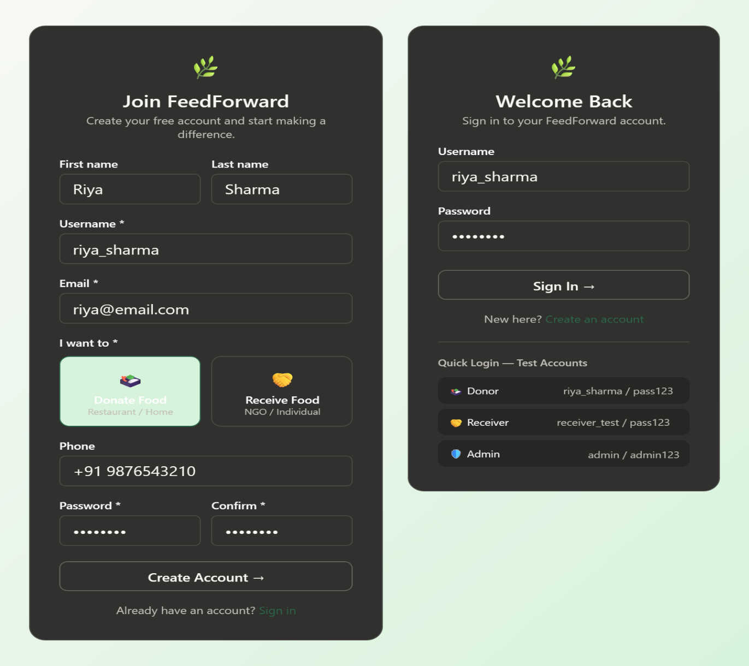
5.3 Screenshot

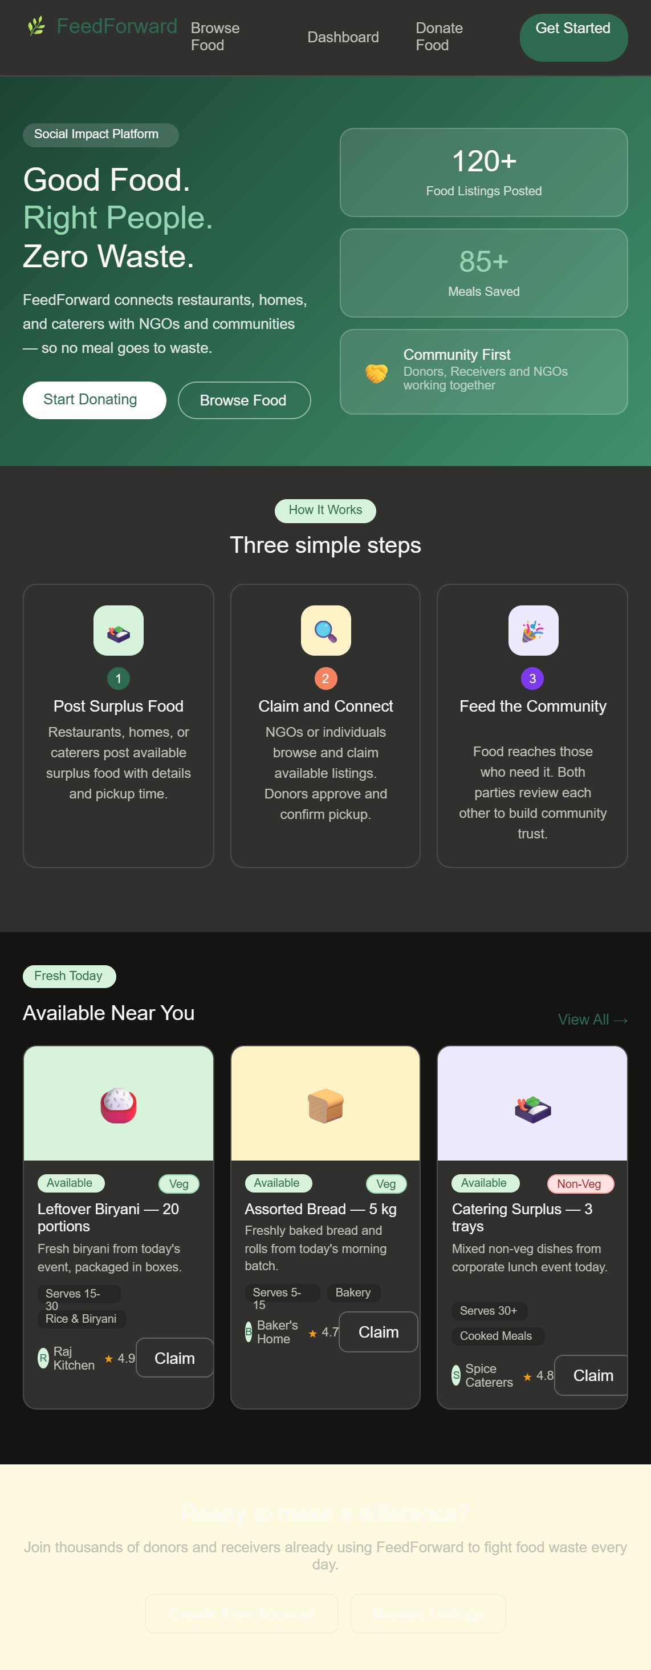

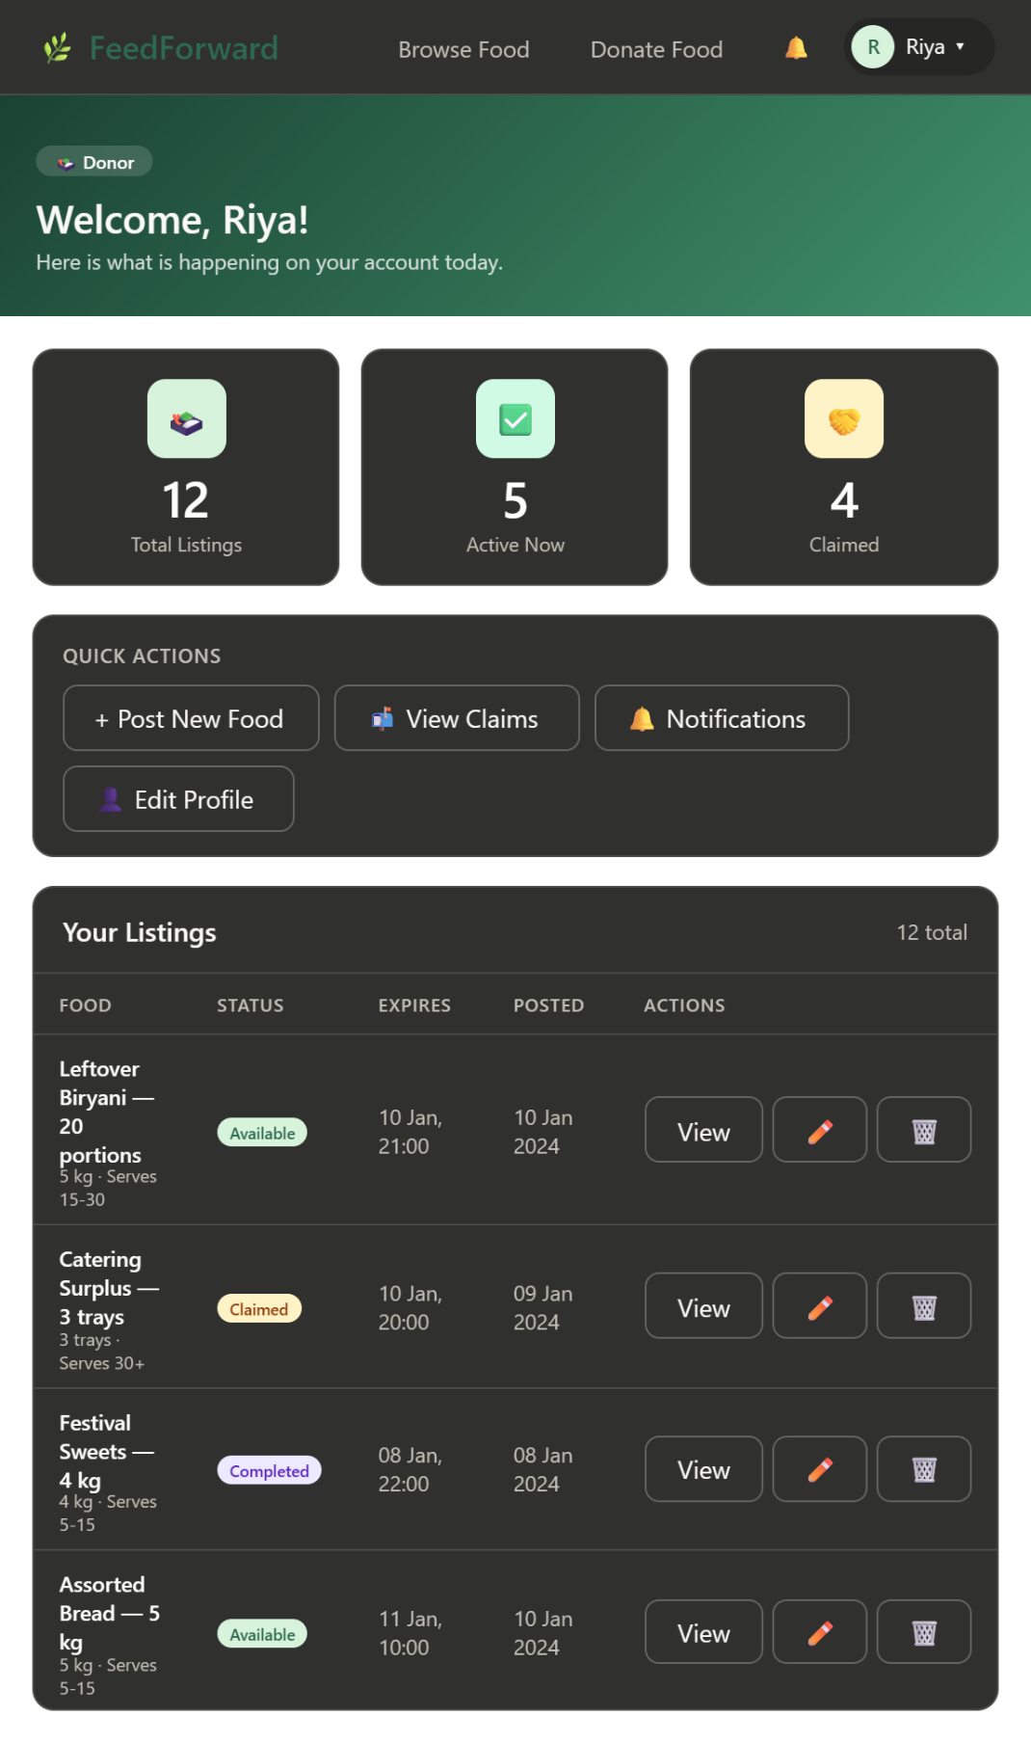

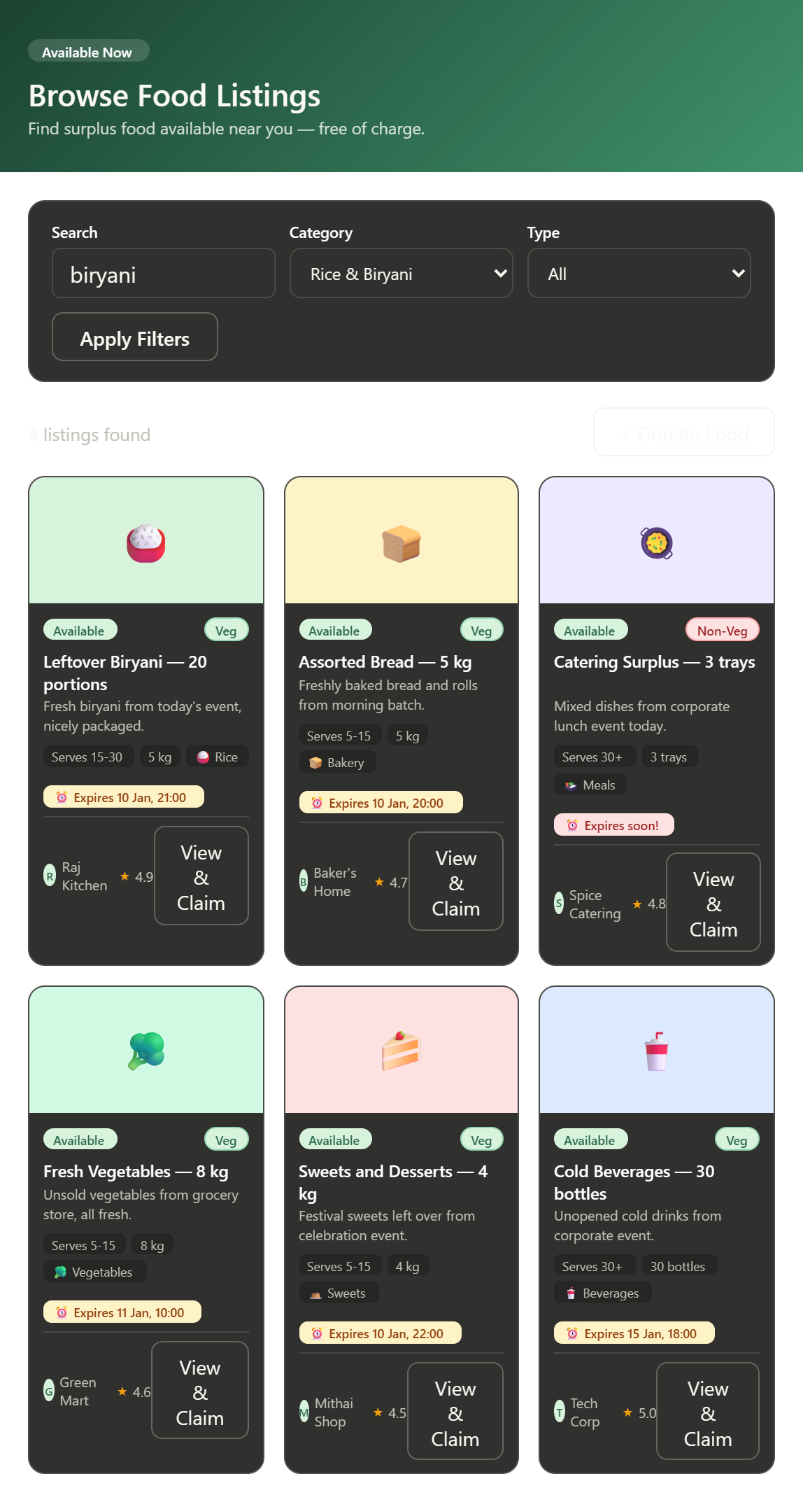

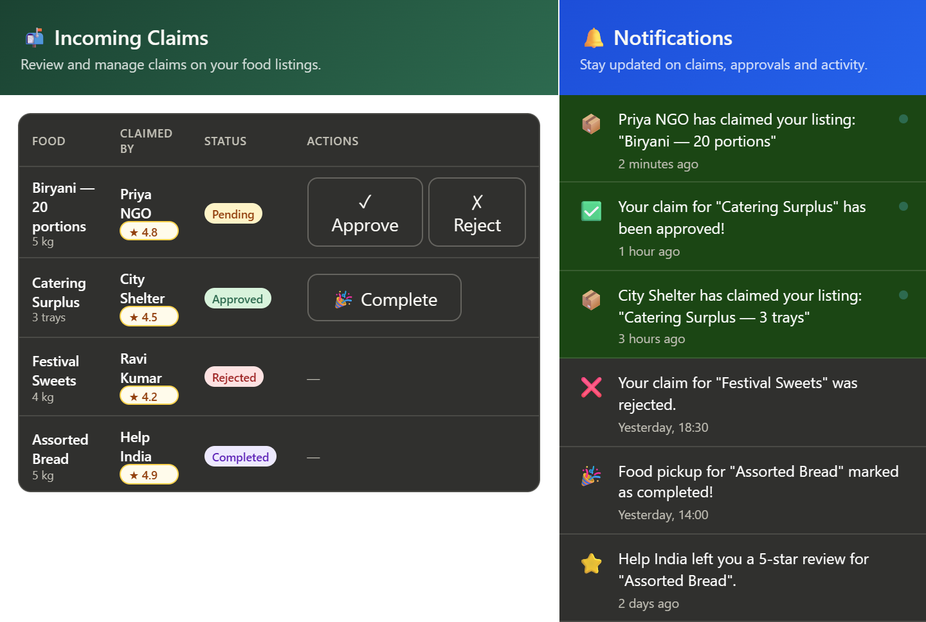

CHAPTER:06 SYSTEM TESTING

System testing is a critical phase in the software development lifecycle that evaluates the complete and integrated application to ensure it meets the specified requirements. For the Food Waste Redistribution Application, system testing was conducted across multiple dimensions including functional correctness, performance, security, and usability. The objective was to validate that all modules of the application work together seamlessly and deliver the intended functionality to the end users.
1. Functional Testing
Functional testing was carried out to verify that each feature of the application performs as expected according to the project requirements. The user registration and login module was tested for all three roles — donor, recipient, and volunteer — to confirm that role-based access is correctly enforced. The food listing module was tested by submitting entries with various combinations of food name, quantity, expiry date, location, and category to verify that the data is accurately stored and displayed. The donor-recipient matching functionality was validated by checking whether the system correctly pairs food listings with nearby recipients based on food type, quantity, and proximity. Notification triggers were also verified to ensure that alerts are sent to recipients when a new food listing is created in their area.
2. User Interface Testing
User interface testing was performed to ensure that the application provides a smooth and intuitive experience for all users. All input forms were tested for proper validation, confirming that empty fields, incorrect formats, and invalid data entries are appropriately handled with meaningful error messages. The responsive design of the application was tested across multiple screen sizes including mobile phones, tablets, and desktop screens to ensure consistent layout and usability. Navigation between different pages and modules was verified to be logical and error-free. The map interface was tested to confirm that donor and recipient locations are accurately plotted and updated in real time.
3. Performance Testing
Performance testing was conducted to evaluate the responsiveness and stability of the application under various load conditions. The application was tested with multiple simultaneous users performing actions such as listing food items, claiming donations, and updating delivery statuses to assess how the system handles concurrent operations. Database query performance was measured when filtering food listings by location, category, and expiry date to ensure results are returned within an acceptable time frame. Image upload functionality for food photos was also tested to verify that uploads complete quickly without degrading the overall app performance.
4. Security Testing
Security testing was performed to identify and address potential vulnerabilities in the application. Authentication mechanisms were tested to confirm that only registered and logged-in users can access protected pages and functionalities. Role-based access control was verified to ensure that donors cannot access recipient-only or admin features, and vice versa. The application was tested against common web vulnerabilities such as SQL injection and Cross-Site Scripting (XSS) to confirm that user inputs are properly sanitized. Password storage was verified to use hashing algorithms, ensuring that plain-text passwords are never stored in the database. Session management was also tested to confirm that sessions expire correctly after logout or inactivity.
5. Integration Testing
Integration testing was conducted to verify that all individual modules and third-party services work correctly when combined. The Google Maps API integration was tested to ensure that location search, distance calculation, and map rendering function accurately within the application. The email and SMS notification service was tested to confirm that alerts are delivered to the correct users at the right time. Database connectivity was validated through end-to-end CRUD (Create, Read, Update, Delete) operations across all major modules including user profiles, food listings, and delivery records.
6. Compatibility Testing
Compatibility testing was performed to ensure the application functions correctly across different environments. The application was tested on multiple web browsers including Google Chrome, Mozilla Firefox, Microsoft Edge, and Safari to verify consistent behavior and appearance. Mobile compatibility was tested on both Android and iOS devices to confirm that the interface adapts properly to different operating systems and screen resolutions. No major compatibility issues were found, and minor UI adjustments were made to ensure uniformity across platforms.
7. Acceptance Testing
Acceptance testing was the final phase of system testing, conducted to confirm that the application meets all the original project objectives. Sample users representing donors, recipients, and volunteers were asked to perform real-world tasks within the application, such as listing surplus food, claiming a donation, and completing a delivery. Feedback was collected to assess ease of use, clarity of instructions, and overall satisfaction. The testing confirmed that the application successfully fulfills its primary goal of reducing food waste by enabling efficient redistribution of surplus food to those in need.

CHAPTER :7 FUTURE ENHANCEMENT

Future Enhancement
The Food Waste Redistribution Application in its current form addresses the fundamental need of connecting food donors with recipients to minimize food wastage. However, as technology continues to evolve and the scale of food insecurity grows, there is significant scope for enhancing the application with more advanced features and capabilities. The following enhancements are proposed for future development phases to make the platform more intelligent, efficient, and impactful.
1. Real-Time Expiry Detection Using OCR and Barcode Scanning
To further reduce food wastage, a real-time expiry detection feature can be integrated into the application. Donors would be able to scan product barcodes or use the phone camera to capture expiry dates printed on food packaging using Optical Character Recognition technology. The application would then automatically read and record the expiry date, categorize the urgency of redistribution, and trigger instant alerts to nearby recipients. This feature would be particularly useful for supermarkets and restaurants that handle large quantities of packaged food and may find it time-consuming to manually enter expiry information for every item.
2. Volunteer and Delivery Network Integration
The current version of the application focuses primarily on connecting donors and recipients but does not fully address the logistics of physical food transport. A future enhancement would involve building a dedicated volunteer and delivery network module where community members can register as delivery volunteers. Volunteers would receive real-time notifications about nearby food pickups, accept delivery requests, and update the delivery status within the app. Route optimization using Google Maps API can also be integrated to help volunteers plan the most efficient multi-stop delivery routes, saving time and reducing transportation costs.
3. Cold Chain Monitoring for Perishable Items
For food items that require temperature-controlled transport such as dairy products, cooked meals, and fresh produce, a cold chain monitoring system can be integrated in the future. IoT-enabled temperature sensors placed in delivery bags or vehicles would continuously track the temperature of food during transit and send real-time data to the application. If the temperature exceeds safe limits, an immediate alert would be triggered to the volunteer or delivery partner. This enhancement would significantly improve food safety standards and ensure that perishable donations reach recipients in a consumable condition.
4. Impact Dashboard and Gamification
To encourage more donors to participate actively on the platform, a personalized impact dashboard and gamification system can be introduced. The impact dashboard would display meaningful statistics to each donor such as the total kilograms of food saved, the number of meals provided, and the equivalent amount of carbon dioxide emissions prevented through their donations. Gamification elements such as achievement badges, reward points, and leaderboards would add a competitive and motivational dimension to the donation process. Donors who consistently contribute would earn higher rankings and recognition within the community, fostering a culture of social responsibility and regular participation.
5. Multi-Language Support and Offline Mode
Since food insecurity is a widespread issue that affects diverse communities across different regions of India and the world, the application can be enhanced with multi-language support to make it accessible to users who are not comfortable with English. Languages such as Tamil, Hindi, Telugu, and Kannada can be integrated to reach a broader user base. Additionally, an offline mode can be developed to allow users in areas with poor or no internet connectivity to still browse food listings, submit donations, and receive notifications once the connection is restored. These enhancements would greatly improve the inclusivity and reach of the platform.

CONCLUSION

Feedforward is a web-based food waste redistribution platform developed as a Final Year Project using Python and the Django web framework. The project was conceived with a clear and meaningful purpose — to address the growing problem of food waste by building a digital bridge between food donors and food receivers within a structured, transparent, and trust-driven environment.
The development of Feedforward successfully demonstrates how modern web technologies can be applied to solve real-world social and humanitarian challenges. By providing a centralised platform where donors can post surplus food listings and receivers can browse, claim, and collect available food, the system eliminates the fragmented and unreliable informal methods that currently exist for food redistribution — such as personal phone calls, WhatsApp messages, and social media posts — and replaces them with a systematic, accountable, and scalable digital solution.
Throughout the course of this project, all defined objectives were achieved completely and successfully. A fully functional CRUD web application was built using Django and Python, incorporating six independent but interconnected modules: Users, Listings, Claims, Reviews, Notifications, and the Admin Panel. A robust role-based access control system was implemented to support three distinct user types — Donor, Receiver, and Admin — each with a personalised dashboard, clearly defined permissions, and a tailored user experience. The complete end-to-end food donation workflow was developed and tested, covering every stage from posting a listing to completing an exchange and leaving a review. An attractive, responsive user interface was built using Bootstrap 5 and custom CSS, ensuring accessibility across all devices and screen sizes. An automatic in-app notification system was integrated to keep all users informed at every key stage of the workflow. A community trust and rating system was implemented to promote accountability and credibility among platform participants.

BIBLOGRAPHY
- Food and Agriculture Organization of the United Nations (FAO). (2019). The State of Food and Agriculture: Moving Forward on Food Loss and Waste Reduction. FAO Publications. Rome, Italy. Retrieved from https://www.fao.org
- Gustavsson, J., Cederberg, C., Sonesson, U., van Otter Dijk, R., & Maybeck, A. (2011). Global Food Losses and Food Waste: Extent, Causes and Prevention. Food and Agriculture Organization of the United Nations, Rome.
- Ministry of Food Processing Industries, Government of India. (2022). Annual Report on Food Processing and Waste Management in India. New Delhi. Retrieved from https://www.mofpi.gov.in
- Food Safety and Standards Authority of India (FSSAI). (2021). Guidelines for Food Donation and Redistribution in India. New Delhi. Retrieved from https://www.fssai.gov.in
- Refed. (2021). Insights Engine: Food Waste Monitor and Redistribution Strategies. Retrieved from https://www.refed.org
- Papargyropoulou, E., Lozano, R., Steinberger, J. K., Wright, N., & Ujang, Z. B. (2014). The food waste hierarchy as a framework for the management of food surplus and food waste. Journal of Cleaner Production, 76, 106–115.
- Thyberg, K. L., & Tonjes, D. J. (2016). Drivers of food waste and their implications for sustainable policy development. Resources, Conservation and Recycling, 106, 110–123.
- Kumar, A., & Singh, R. (2020). Mobile Application Based Food Waste Redistribution System for Urban Areas. International Journal of Computer Applications, 175(12), 34–39.
- Google Developers. (2023). Google Maps Platform Documentation — Directions API and Distance Matrix API. Retrieved from https://developers.google.com/maps
- Amazon Web Services. (2023). AWS Cloud Services for Mobile and Web Application Development. Retrieved from https://aws.amazon.com
- Android Developers. (2023). Android Studio and Mobile App Development Guide. Retrieved from https://developer.android.com
- Firebase by Google. (2023). Firebase Documentation — Realtime Database, Authentication, and Cloud Messaging. Retrieved from https://firebase.google.com
- Feeding India. (2022). Annual Impact Report: Rescuing Food and Feeding Communities Across India. Zomato Feeding India Initiative. Retrieved from https://www.feedingindia.org
- No Food Waste NGO. (2022). Food Redistribution Operations and Technology Use in Tamil Nadu. Retrieved from https://www.nofoodwaste.org
- Sommerville, I. (2016). Software Engineering (10th ed.). Pearson Education Limited. London, United Kingdom.
- Pressman, R. S., & Maxim, B. R. (2020). Software Engineering: A Practitioner's Approach (9th ed.). McGraw-Hill Education. New York, United States.
- Date, C. J. (2019). An Introduction to Database Systems (8th ed.). Pearson Education. New Delhi, India.
- Forouzan, B. A. (2017). Data Communications and Networking (5th ed.). McGraw-Hill Education. New Delhi, India.

